**Hold Shift and Check Checkboxes**

In this exercise we want to be able to check a box and then check an different box and then all boxes that were between the first two checked will be automatically checked as well.

So first we need to listen to the checked boxes

const checkboxes **=** **document.**querySelectorAll('.inbox input[type="checkbox"]');

now we need to listen to when one of them gets clicked or changed

checkboxes**.**forEach(checkbox => checkbox**.**addEventListener('click', handelCheck));

so when someone clicks it we will run a function called handelCheck. So we need to write a function above.

function handelCheck(event) {

**console.**log(event); }

now we need to log where when we check the first box we need to put that into a variable. Because when you check you second one and your holding down shift we need to know what that last one was

so we are going to make a variable called

let lastChecked;

and why we are using let is because it will be reassigned constantly. And lastly we will put in

lastChecked **=** this;

in the handelCheck function

so now when we click one and in our console type lastChecked

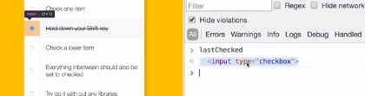

Then we want to check if they have the shift key down

**if**(event**.**shiftKey)

but also check if they are checking it

so if they are pressing the shift key And they are checking the box

**if**(event**.**shiftKey **&&** this**.**checked) {

so what we are going to do is loop over every single checkbox and look for the first one that was checked and then once found continue to check boxes till a new checked box was found and then stop checking boxes

so we will make a variable called in-between

let inBetween **=** false;

then we well loop over every checkbox

checkboxes**.**forEach(checkbox => {

**console.**log(checkbox);

so now if we click one

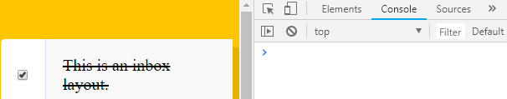I get nothing

But if I hold the shift key and click another one

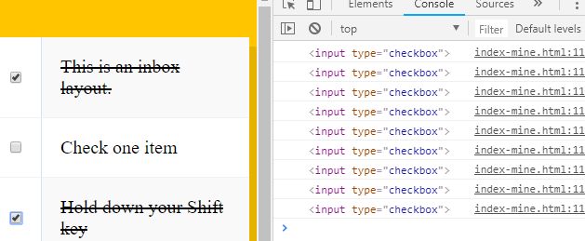so we got every single checkbox along the way. Now we need to figure out as we are looping thru this we need to set the inbetween variable to true

**if**(checkbox **===** this **||** checkbox **===** lastChecked) {

inBetween **=** **!**inBetween;